Q1



Q2

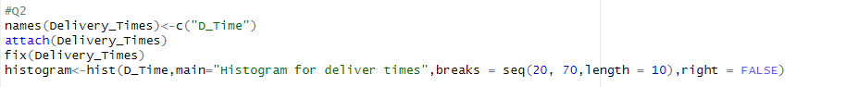



Q4

